Chick Analysis

Elea McDonnell Feit

1/18/2018

# Data

This was data provide to me by Dr. Sue McDonnell on chick growth. This was data from an experiment where….

chickdata <- read.csv("rhea.tables.grams.20150626.csv")  
glimpse(chickdata)

## Observations: 35  
## Variables: 10  
## $ treatment <fct> Treatment: Voluntary Walk-On, Treatment: Voluntary Wal…  
## $ chick <int> 1667357, 1670335, 1680454, 1660777, 1680457, 1667737, …  
## $ breading_group <fct> non, non, non, non, non, non, non, non, non, non, non,…  
## $ hatch_date <fct> 5/29, 5/30, 5/30, 5/30, 5/31, 6/2, 6/8, 6/9, 6/9, 6/10…  
## $ grams_day0 <dbl> 362.88, 408.24, 399.17, 449.06, 430.92, 435.46, 426.38…  
## $ grams_day10 <dbl> 426.38, 444.53, 453.60, 453.60, 426.38, 435.46, 399.17…  
## $ grams_day25 <dbl> 916.27, 1106.78, 1161.22, 1215.65, 1115.86, 952.56, 10…  
## $ pct_gain_10.25 <dbl> 114.89, 148.98, 156.00, 168.00, 161.70, 118.75, 152.27…  
## $ gender <fct> f, m, f, m, m, m, f, m, f, m, f, f, m, m, f, NA, m, NA…  
## $ color <fct> b, b, b, b, b, w, b, b, b, b, b, w, b, b, b, w, b, w, …

summary(chickdata)

## treatment chick breading_group  
## Control: Involuntary Bucket :17 Min. : 167633 breeder:14   
## Treatment: Voluntary Walk-On:18 1st Qu.:1667170 non :21   
## Median :1667934   
## Mean :1626957   
## 3rd Qu.:1671362   
## Max. :1680841   
##   
## hatch_date grams_day0 grams_day10 grams_day25 pct_gain_10.25   
## 5/30 :11 Min. :317.5 Min. :308.4 Min. : 517.1 Min. : 16.33   
## 5/29 : 6 1st Qu.:383.3 1st Qu.:408.2 1st Qu.: 821.0 1st Qu.: 99.72   
## 6/9 : 6 Median :403.7 Median :426.4 Median : 997.9 Median :134.69   
## 5/31 : 5 Mean :403.3 Mean :433.8 Mean :1033.9 Mean :138.99   
## 6/10 : 3 3rd Qu.:426.4 3rd Qu.:453.6 3rd Qu.:1211.1 3rd Qu.:172.34   
## 5/28 : 2 Max. :476.3 Max. :535.2 Max. :1705.5 Max. :290.48   
## (Other): 2   
## gender color   
## f :15 b:27   
## m :18 w: 8   
## NA's: 2   
##   
##   
##   
##

Create a scatterplot showing the relationship between grams at day 0 and grams at day 25.

plot(grams_day25 ~ grams_day0, data=chickdata)

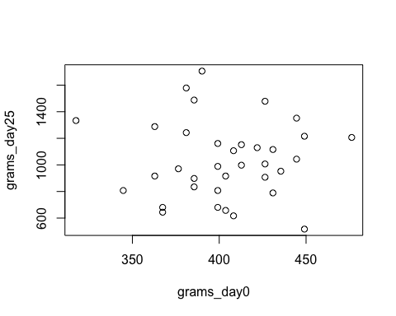

ggplot(data=chickdata, aes(x=grams_day0, y=grams_day25)) +   
 geom_point()

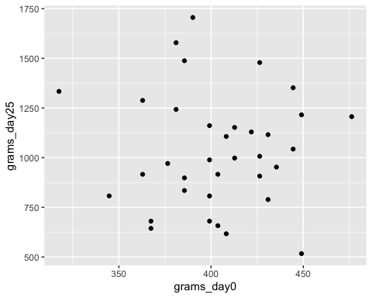

A boxplot shows the relationship between a continuous response variable and a discrete or categeorical explanatory variable. An alternative is the beanplot. Mom, this beanplot shows that the data is really noisy and it doesn’t look like the hypothized effect is present. I’m so sorry for your loss.

boxplot(pct_gain_10.25 ~ treatment, data=chickdata)

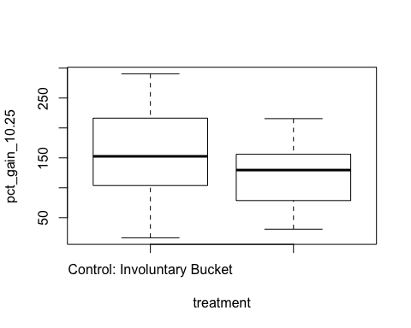

library(beanplot)  
beanplot(pct_gain_10.25 ~ treatment, data=chickdata,  
 col=c("lightgray", "black", "black", "red"),   
 ylab="percent",   
 main="Percent Weight Gain Day 10 to Day 25,26")

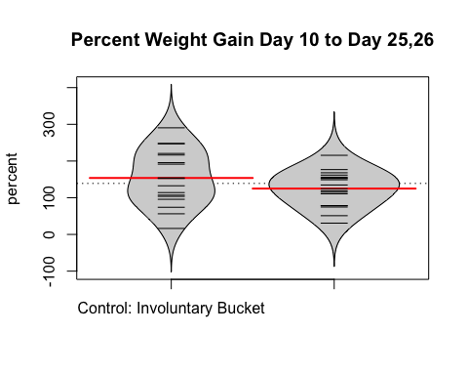

A t-test indicates the difference in percent weight gain is non-significant.

t.test(pct_gain_10.25 ~ treatment, data=chickdata)

##   
## Welch Two Sample t-test  
##   
## data: pct_gain_10.25 by treatment  
## t = 1.3366, df = 26.66, p-value = 0.1926  
## alternative hypothesis: true difference in means is not equal to 0  
## 95 percent confidence interval:  
## -15.49256 73.29871  
## sample estimates:  
## mean in group Control: Involuntary Bucket   
## 153.8553   
## mean in group Treatment: Voluntary Walk-On   
## 124.9522

simplemodel <- lm(pct_gain_10.25 ~ (treatment + gender + color + breading_group)^2 , data=chickdata)  
summary(simplemodel)

##   
## Call:  
## lm(formula = pct_gain_10.25 ~ (treatment + gender + color + breading_group)^2,   
## data = chickdata)  
##   
## Residuals:  
## Min 1Q Median 3Q Max   
## -124.593 -30.823 0.602 26.537 107.474   
##   
## Coefficients:  
## Estimate Std. Error  
## (Intercept) 156.118 39.402  
## treatmentTreatment: Voluntary Walk-On -57.205 47.826  
## genderm -12.245 48.383  
## colorw -70.916 55.271  
## breading_groupnon 26.888 48.383  
## treatmentTreatment: Voluntary Walk-On:genderm -8.042 46.100  
## treatmentTreatment: Voluntary Walk-On:colorw 127.158 64.213  
## treatmentTreatment: Voluntary Walk-On:breading_groupnon 25.866 47.476  
## genderm:colorw -140.911 89.496  
## genderm:breading_groupnon 10.082 54.312  
## colorw:breading_groupnon 83.470 88.489  
## t value Pr(>|t|)   
## (Intercept) 3.962 0.000661 ***  
## treatmentTreatment: Voluntary Walk-On -1.196 0.244395   
## genderm -0.253 0.802549   
## colorw -1.283 0.212820   
## breading_groupnon 0.556 0.583995   
## treatmentTreatment: Voluntary Walk-On:genderm -0.174 0.863115   
## treatmentTreatment: Voluntary Walk-On:colorw 1.980 0.060316 .   
## treatmentTreatment: Voluntary Walk-On:breading_groupnon 0.545 0.591348   
## genderm:colorw -1.574 0.129644   
## genderm:breading_groupnon 0.186 0.854442   
## colorw:breading_groupnon 0.943 0.355781   
## ---  
## Signif. codes: 0 '***' 0.001 '**' 0.01 '*' 0.05 '.' 0.1 ' ' 1  
##   
## Residual standard error: 62.41 on 22 degrees of freedom  
## (2 observations deleted due to missingness)  
## Multiple R-squared: 0.3436, Adjusted R-squared: 0.04528   
## F-statistic: 1.152 on 10 and 22 DF, p-value: 0.3715

anova(simplemodel)

## Analysis of Variance Table  
##   
## Response: pct_gain_10.25  
## Df Sum Sq Mean Sq F value Pr(>F)   
## treatment 1 4309 4308.6 1.1062 0.30433   
## gender 1 1032 1032.1 0.2650 0.61185   
## color 1 6820 6819.7 1.7509 0.19936   
## breading_group 1 12817 12817.5 3.2907 0.08334 .  
## treatment:gender 1 157 157.4 0.0404 0.84254   
## treatment:color 1 9656 9655.8 2.4790 0.12965   
## treatment:breading_group 1 274 274.3 0.0704 0.79320   
## gender:color 1 6162 6162.2 1.5821 0.22165   
## gender:breading_group 1 168 168.0 0.0431 0.83738   
## color:breading_group 1 3466 3465.7 0.8898 0.35578   
## Residuals 22 85691 3895.0   
## ---  
## Signif. codes: 0 '***' 0.001 '**' 0.01 '*' 0.05 '.' 0.1 ' ' 1